Docker-compose file syntax
In a docker-compose file we are specifying multiple services:
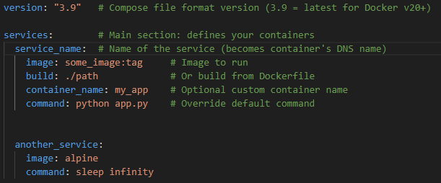
Each service is running a container and we can specify different parameters for it.
More information about useful parameters we can specify there is in the ‘Docker compose useful configurations’ notes in this knowledge base.

Networking
Docker Compose make networking between container’s simpler.
It assigns DNS names to every container we run using Docker Compose. This DNS name is a name of a service in a docker-compose file.

